Dans member

procedure Tfrm_Liste_Membre.Button5Click(Sender: TObject);
begin
datamod.TMembre.Filtered := false;
datamod.TMembre.IndexName := 'I_MB_ID';
frm_liste_sponsor_membre.showmodal;
end;
sur form activate de liste inscription

tmp := datamod.TmembreMB_ID.AsString;
showmessage(QuotedStr(tmp));
datamod.TInscription.Filter := 'IA_MB_ID = ' + QuotedStr(tmp);
datamod.TInscription.Filtered := true;

dans membre
datamod.TMembre.Filtered := false;
datamod.TMembre.IndexName := 'I_MB_ID';
frm_liste_sponsor_membre.showmodal;
dans sponsor
tmp := datamod.TMembreMB_ID.AsString;
datamod.TMbrspo.Filter := 'MS_MB_ID = ' + QuotedStr(tmp);
datamod.TMbrspo.Filtered := true;
dans terminate
datamod.TMbrspo.Filtered := false;
bouton supprimer
if messagedlg('etes vous certain ??',mtconfirmation,[mbyes,mbno],0)=mryes
then
datamod.tbletudiant.delete;
maitre detail
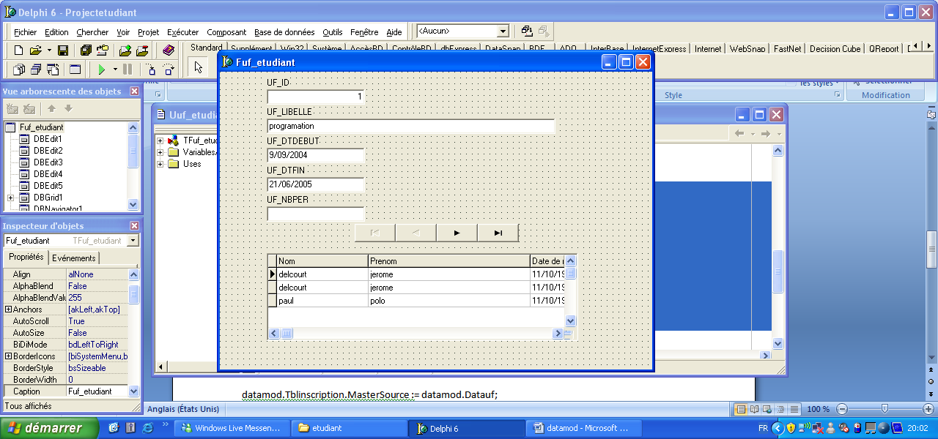
procedure TFuf_etudiant.FormActivate(Sender: TObject);
begin
datamod.Tblinscription.IndexName := 'iins_uf_id';
datamod.Tblinscription.MasterSource := datamod.Datauf;
datamod.Tblinscription.masterfields := 'uf_id' ;
end;

procedure TFuf_etudiant.FormCloseQuery(Sender: TObject;
var CanClose: Boolean);
begin
datamod.Tblinscription.Masterfields := '';
datamod.Tblinscription.mastersource := nil ;
end;

procedure Tfrm_club.Button3Click(Sender: TObject);
begin
showmessage(inttostr(datamod.TClubCL_ID.AsInteger));
frm_liste_cours.DBGrid1.Tag := datamod.TClubCL_ID.AsInteger;
frm_liste_cours.showmodal;
end;
procedure Tfrm_liste_sponsor_membre.FormActivate(Sender: TObject);
var tmp : string;

begin
tmp := datamod.TMembreMB_ID.AsString;
//Dataquery.Query.Active := false;
//DataQuery.Query.SQL.Clear;
//DataQuery.Query.SQL.Add('SELECT SP_NOM');
//Dataquery.Query.SQL.Add('FROM mbrspo.DBF, sponsor.DBF');
//Dataquery.Query.SQL.Add('WHERE (SP_ID = MS_SP_ID) AND (MS_MB_ID = ''' + tmp +''')');
//DataQuery.Query.SQL.Add('GROUP BY SP_NOM');
//Dataquery.Query.Active := true;
datamod.TMbrspo.Filter := 'MS_MB_ID = ' + QuotedStr(tmp);
datamod.TMbrspo.Filtered := true;

end;

procedure Tfrm_liste_sponsor_membre.FormCloseQuery(Sender: TObject;
var CanClose: Boolean);
begin
datamod.TMbrspo.Filtered := false;
end;

procedure Tfrm_liste_sponsor_membre.Button2Click(Sender: TObject);
var tmp:string;
begin
tmp := datamod.TMembreMB_ID.AsString;
datamod.TMbrSpo.edit;
datamod.TMbrSpoMS_MB_ID.AsString := tmp;
If (DataMod.TMbrSpo.State = DsEdit) or (DataMod.TMbrSpo.State = DsInsert) then DataMod.TMbrSpo.Post;
close;
end;

